**Resource Constrained Optimized Scheduling of Hydrotesting Activities**

The resource constrained scheduling of hydrotesting activities is a joint study conducted by PCL Construction and the Department of Construction Management at University of Houston (UH CM). The goal of the study is to develop a software program that generates optimized schedules of hydrotesting activities considering important criteria such as overall duration, flow of work, and resource leveling. The project is conducted in two phases. The first phase is an exploratory one that spanned for three months (April to June 2019). On the other hand, the second phase will span for twelve months (July 1st to June 30st).

1. **Exploratory Phase (September 2018 – March 2019)**

In the exploratory phase, the UH CM team assessed the feasibility of developing an optimization software program based on the problem statement and solutions obtained from PCL Construction. The UH CM team, which included one faculty member, a software developer, and a CM graduate student, developed a software program that can automatically conduct the schedule optimization of hydrotesting activities.

* 1. **Scope**

The work scope completed by the UH CM team is listed below.

1. Create lists of inputs and outputs of the software program based on discussions with PCL Construction.
2. Create functions to process the PCL Construction data in the forms that can be used for schedule optimization
3. Adapt Genetic Algorithm to multi-objective optimization solution for research constrained schedule optimization
4. Develop a prototype software program and test the software program to create optimized schedules for hydrotesting activities based on project conditions set by PCL construction.

The developed software program provides very basic functionalities and requires further development.

* 1. **Development**

A POC software has been developed. Following is a description of the development:

1. April
   1. Discussed requirements and formalized the problem statement
   2. Studied and analyzed the testing data provided by PCL
   3. Developed functions to extract testing information from the raw data contained in excel files

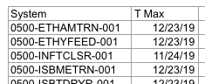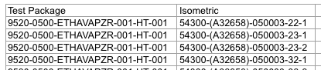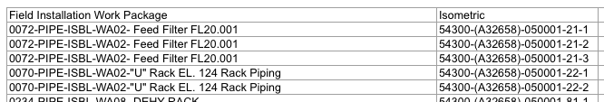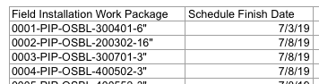

1. May
   1. Developed basic software functionalities and GUI
   2. Implemented single objective genetic algorithm optimization for ‘Resource variation’ and ‘Project duration’
   3. Implemented multi-objective optimization
   4. Developed scatter plot, gantt chart and bar chart for visualization of results

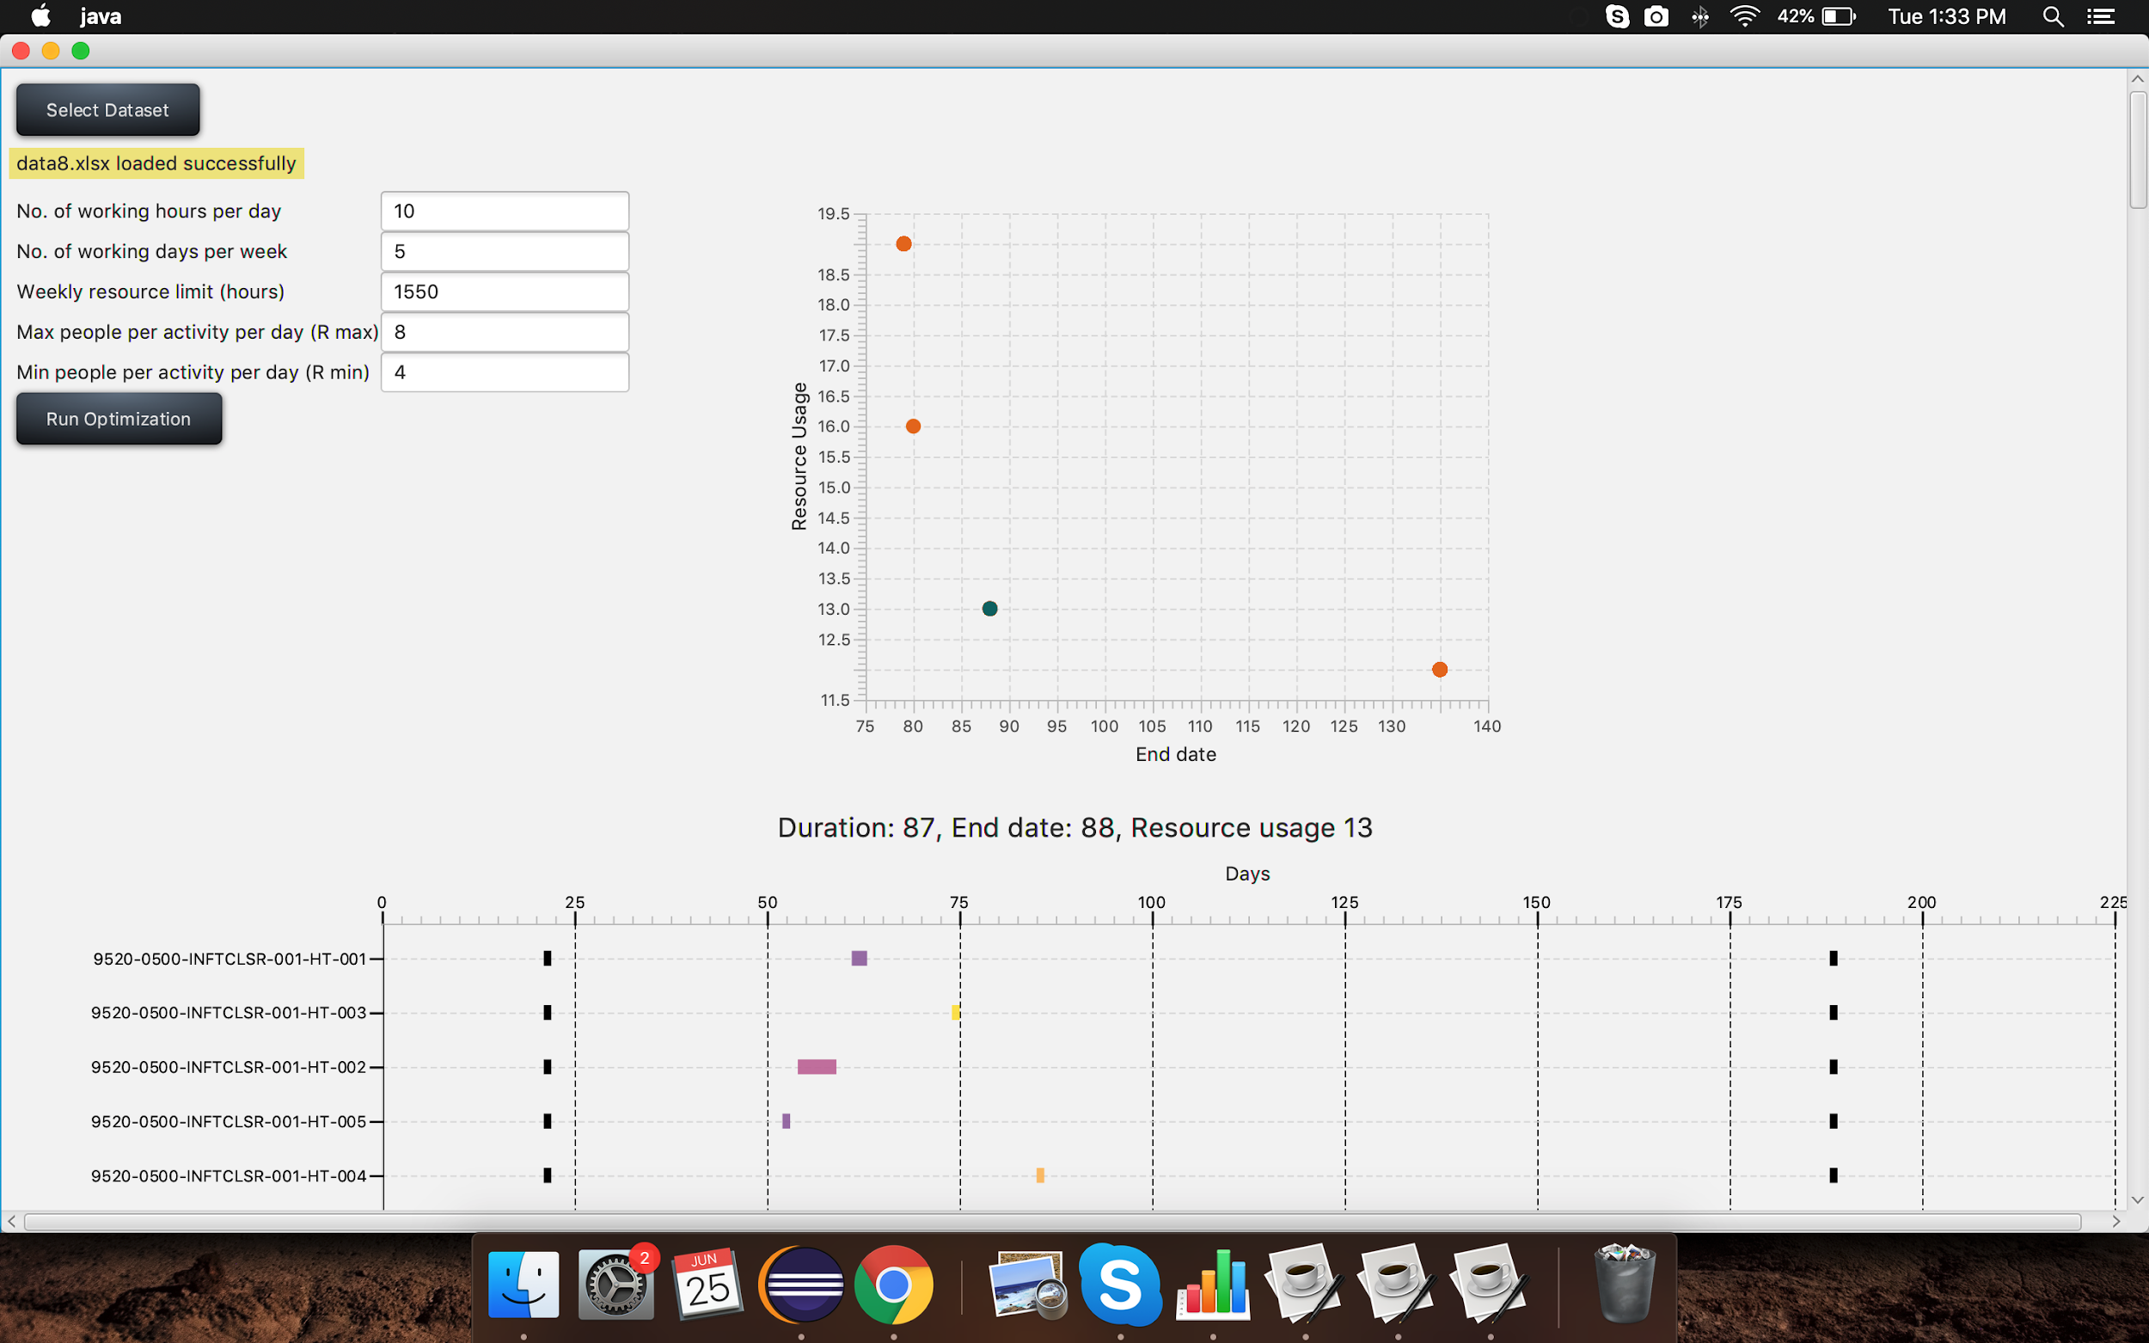

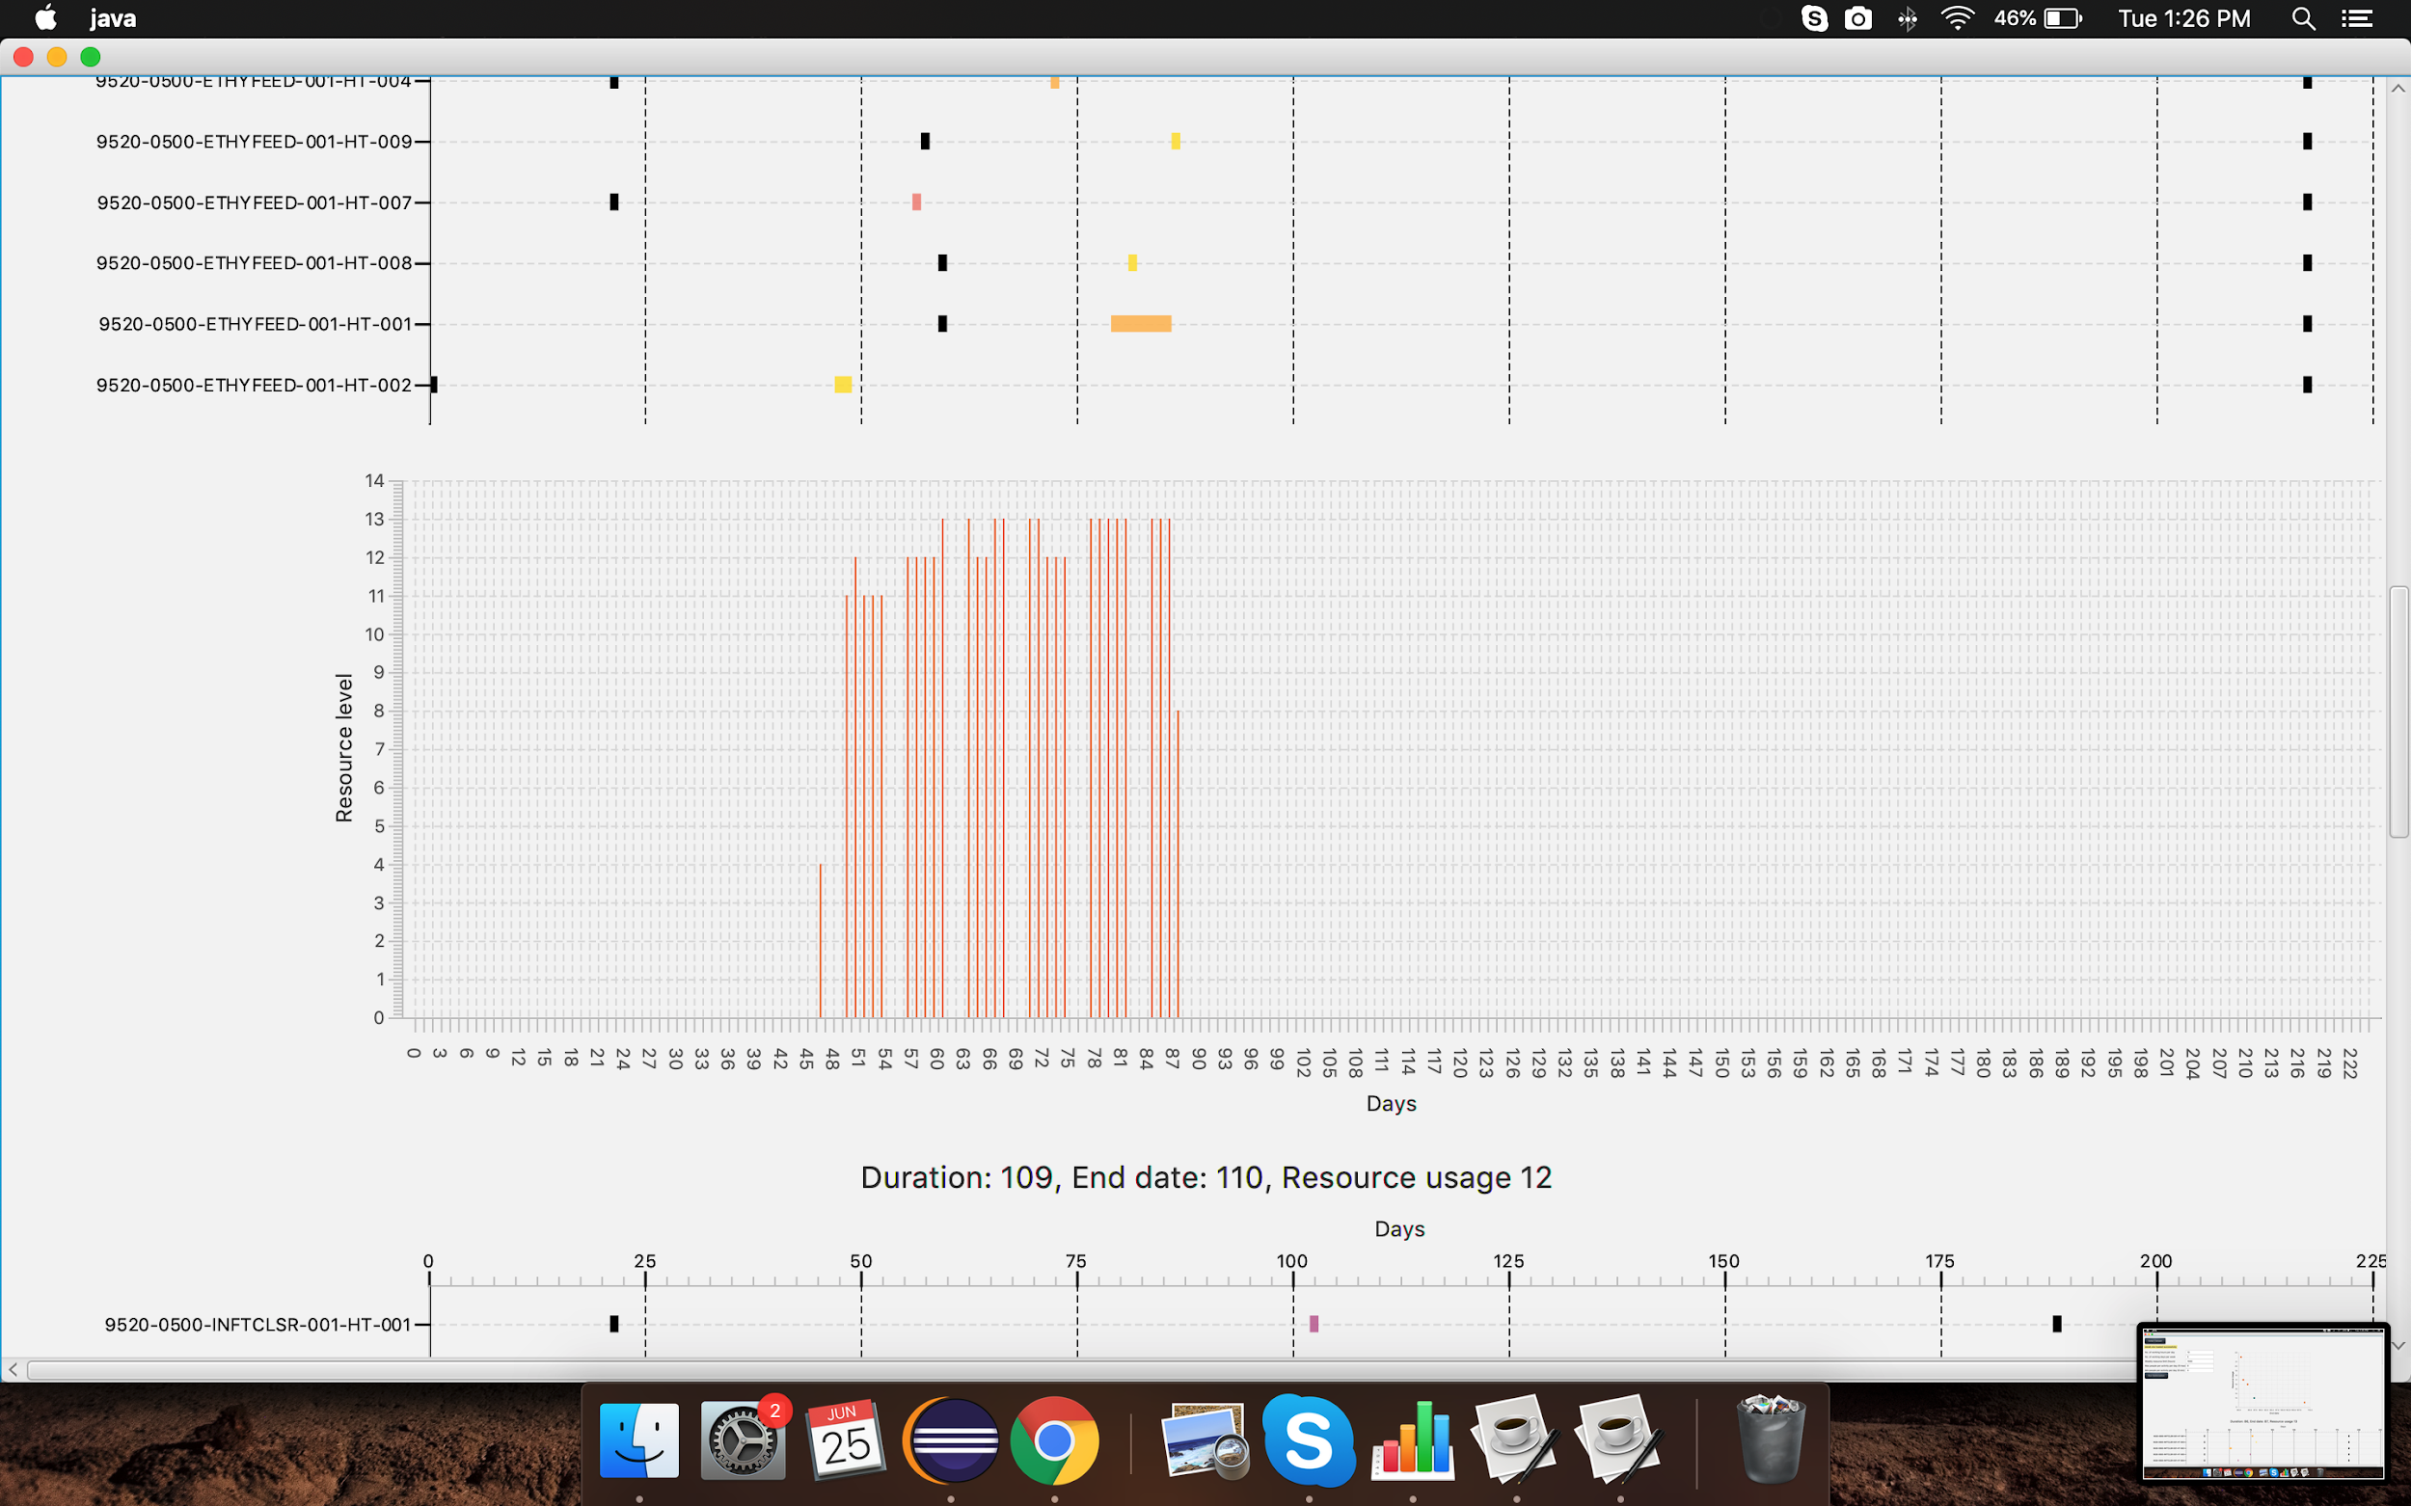

1. June
   1. Tried out different objective functions to come up with better resource distribution
   2. Implemented variable T max instead of fixed T max

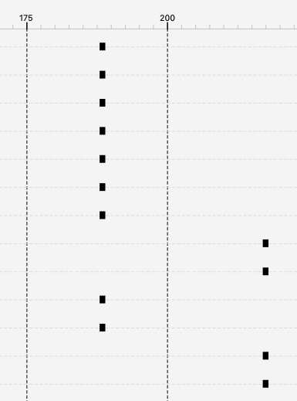

* 1. Implemented calculations based on calendar days instead of work days

* 1. **Budget**

The time and budget contributed by the Department of Construction Management at UH is shown below.

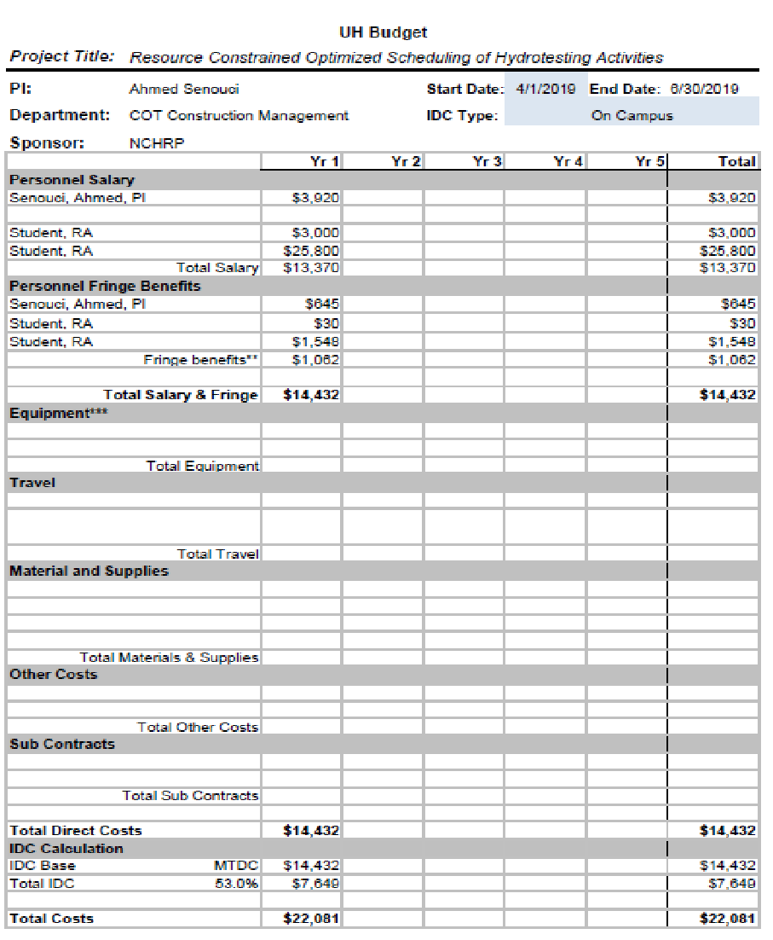

1. **Development Phase (July 2019 – June 2020)**

The exploratory phase demonstrated the feasibility of the proposed research constrained schedule optimization. In the development phase, the research team will focus on developing the software program with full capabilities of the essential functions based on PCL Construction requirements and practices. Then, the CM UH project team will work on customization of the functions and GUI to provide additional options to the users.

* 1. **Scope**

The proposed work scope is shown below:

1. **Graphic User Interface**
   1. A Graphic User Interface (GUI) will be developed that users can provide input for schedule optimization and view the results in various forms (e.g. schedules and plots)
2. **Data Import and Consolidation**
   1. Create interface to import and store various tables required for processing
   2. Provide feedback through report or indicators of incomplete data model for processing
3. **Schedule Optimization**
   1. Multi-objective schedule optimizations will be improved in speed and accuracy in finding number of acceptable solutions
4. **Visualization**
   1. Methods of fine-tuning acceptable results to include the ability to adjust (in Gantt chart)
      1. Peak Craft Levels
      2. Acceptable variation in week-to-week resource requirements (%)
      3. Earliest Start Date
5. **Automate Deliverables**
   1. A method will be developed to automatically generate all the deliverables (forms, histograms, schedules, etc.) accessible from the GUI.
   2. Must be able to print Gantt bar chart with resource curve from application.
   3. Requirements to export results via excel spreadsheets that can easily be imported into Primavera P6, with associated schedule logic.
6. **Validation**
   1. Run algorithm on 3 previous PCL projects to understand the time distribution of earned hours over the course of a hydrotest and to validate resource usage for a single test package.
7. **Run on Pilot PCL Project**
   1. The developed system will be implemented on a current PCL project to determine if efficiencies can be discovered.
8. **Installation Work Package Feedback**
   1. Investigate ability to apply algorithm to piping Installation Work Packages (IWPs) and provide feedback for potentially out-of-sequence work, or IWPs that need to be revised/re-planned, to create a more efficient hydrotesting schedule.
9. **Work Schedule**

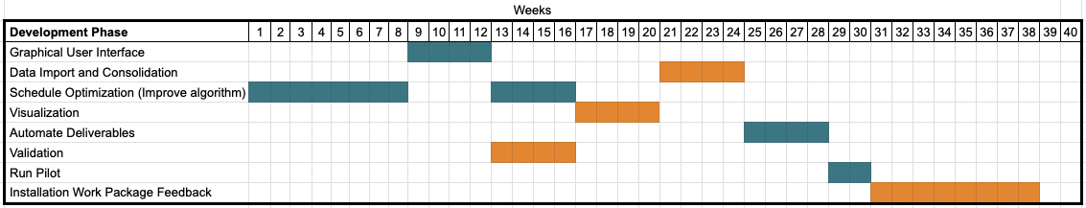

1. **Task Schedule** (I will take care of this section)
2. **Budget**  (I will take care of this section)